

2022
Year 11 Integrated Science – Unit 2
Task 7: Atomic Structure and Chemical Reactions Test
MARKING KEY
Assessment Type: |  | Name:
Test
Duration & Conditions:  1 hour, test conditions |  | Teacher:
Assessment weighting:  5 % of year mark |  | Date:

Section | Marks
Part One: Multi-choice | $${}/{15}$$
Part Two: Short Answer | $${}/{marks}$$
Total Mark | $${}/{marks}$$

Please see SEQTA for Teacher feedback and comments

PART ONE: MULTI-CHOICE
Please answer the below questions on your answer sheet, not in this booklet.
- What scientific term describes a combination of two or more substances?
  - Mixture
  - Solvent
  - Infusion
  - Sediment

- Which of the following describes a substance that cannot dissolve in a liquid?
  - Filtrate
  - Insoluble
  - Residue
  - Solute

- When brewing alcoholic beverages, both toxic methanol and drinkable ethanol is produced. The boiling point of methanol is lower than the boiling point of ethanol. Which of the following separation techniques utilise this knowledge to separate methanol from ethanol?
  - Distillation
  - Evaporation
  - Filtration
  - Decanting

- Which of the following is the most appropriate separation method for isolating salt from seawater?
- Evaporation
- Decantation
- Winnowing
- Sieving

- Which of the following best describes an element?
- the smallest unit of matter
- a pure substance made of a single type of atom
- a group of two or more types of atoms that are bonded together
- any substance made of two or more types of atom

- Which of the following describes a lasting attraction between two atoms?
- Condensation
- Fusion
- Sublimation
- Bonding

- Water is an example of a compound substance. Which of the following best describes what a compound is?
- a fluid that conforms to the shape of its container
- a pure substance made up of only one type of atom
- a substance made up of two or more different types of atoms bonded together
- a combination of two or more elements that are not chemically bonded

- Which of the following is the best example of a physical change?
- ice turning into water
- wood burning to form a black ash
- baking soda in vinegar producing gas bubbles
- caramelisation of sugar

- Which of the following is a physical property?
- elasticity
- reactivity
- toxicity
- flammability

- Which of the following best describes a proton?
- a positively charged subatomic particle found in the nucleus of an atom
- a positively charged ion
- a negatively charged subatomic particle that moves around the nucleus of an atom
- an uncharged subatomic particle found in the nucleus of an atom

- Atoms are basic units and the building blocks of matter. What is the nucleus of an atom made up of?
- protons and electrons
- neutrons and electrons
- protons and neutrons
- neutrons, protons, and electrons

- What is the electric charge of an electron?
- positive
- negative
- neutral
- none of the above

- Which of the following best shows that a chemical change has taken place?
- solid turning to liquid
- change in shape
- bubbles forming
- change in size

- What are the substances present at the start of a chemical reaction called?
- products
- catalysts
- precipitates
- reactants

- Which of the following must be present for a combustion reaction to occur?
- hydrocarbon
- carbon monoxide
- water
- carbon dioxide

PART TWO: SHORT ANSWER
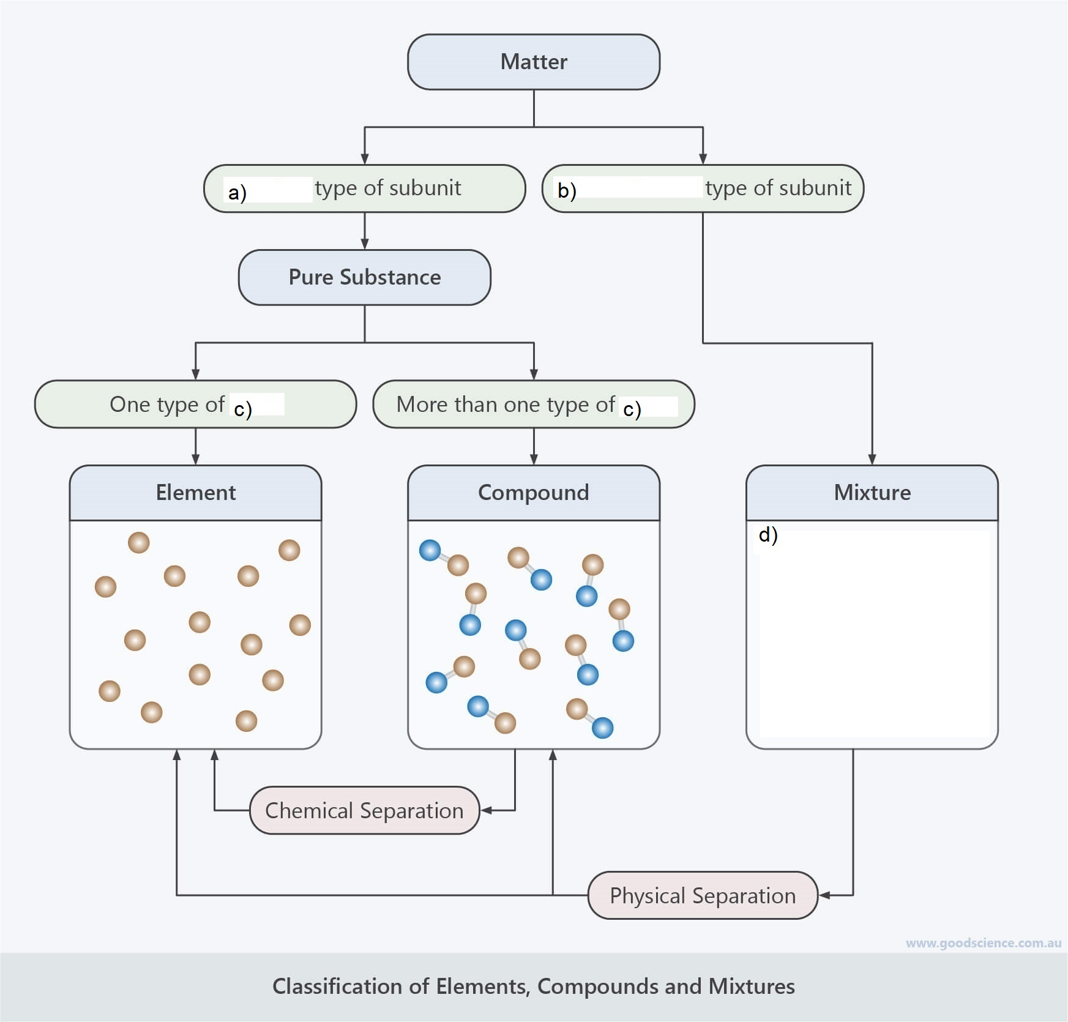
- Complete the below diagram that (a, b, c, d) compares the differences between pure substances and mixtures. (5 marks)
atom
atom
multiple
one

- Identify each of the following as a pure substance or mixture by ticking the appropriate cell (5 marks)
Substance | Pure | Mixture
Cake |  | a
Sugar | a
Diamond | a
Vegetable soup |  | a
Aluminium | a
- Most matter on earth exists in three different states: solid, liquid and gas. Draw lines to match each state of matter to the correct description. (3 marks)
State of Matter |  | Description
Solid |  | Takes up a fixed amount of space, but its shape changes to match its container
Liquid |  | Takes up all available space,  but can be compressed
Gas |  | Has a definitive shape  that cannot be changed easily

- Are changes of state an example of physical or chemical change? Explain your answer using your knowledge of the particle model and chemical bonding. (4 marks)
1 mark – physical change
3 marks – explains that change in state can be reversed. No change in chemical structure of elements, simply rearranged. ____________________________________________________________________________________________________________________________________________________________________________________________________________________________________________________________________________________________________________________________________________________
- You find an unknown substance in your backyard that you suspect may be made of pure metal. List three (3) common properties shared by metals that you could use to check. (3 marks)

- _________________________________________
- _________________________________________
- _________________________________________
1 mark per property of either: malleable, ductile, lustre (shiny), conduct heat, conduct electricity, dense

- Kevin left a frying pan outside during winter. After a few weeks of heavy rain, Kevin noticed that the pan’s surface was covered in an orange-red flaky substance.
  - What is the orange-red substance called? (1 mark)
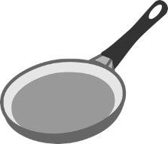
rust _________________________________________

A chemical reaction took place between the iron from the frying pan and oxygen in the air to form the substance.
  - Identify the reactant(s) in this chemical reaction (1 mark)
___________________________________________ iron, oxygen

- What is the definition of a product in a chemical reaction? (2 marks)
__________________________________________________________________________________
The substance formed as the result of a chemical reaction
- To create energy for growth, repair, and any exercise an organism needs to do, it undergoes cellular respiration.
An incomplete word equation representing the cellular respiration with the presence of oxygen is shown below.
$$carbohydrates+oxygen→carbon dioxide+water+energy$$
- Complete the above equation using appropriate words (2 marks)
- What is the type of chemical reaction represented by the above equation? (1 mark)
________combustion____
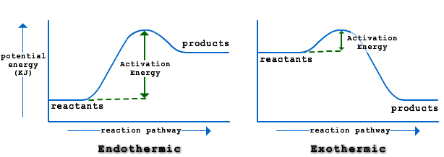
- Chemical reactions can either be endothermic or exothermic. With the help of the below diagram, explain the differences between the two types of reactions. (4 marks)

1 mark – exothermic releases energy
1 mark – endothermic absorbs energy
2 marks – explain differences in activation energy
__________________________________________________________________________________________________________________________________________________________________________

